**2. Expense Tracker**

Another great app idea to build first, as a React Native newbie, could be an Expense Tracker app. From a beginners perspective, building a simple expense tracking app can be a great way to learn the basics of React Native. You’ll learn to create several basic implementations, react components and plugins, that are important to get started with your mobile application development process.

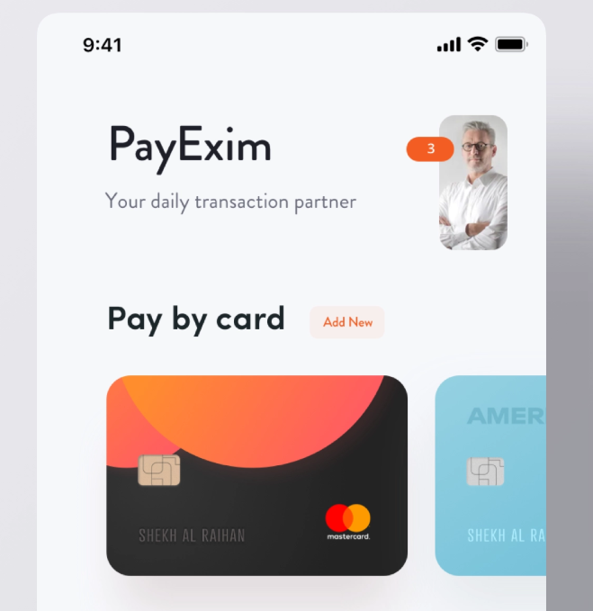[Dribbble](https://dribbble.com/shots/6465141-Personal-Account-Manager-App-Ui/attachments)

Using your knowledge and creativity, you can create your own version of a Budget app in React Native. You can use an existing mobile app as inspiration, such as [**Wallet**](https://play.google.com/store/apps/details?id=com.droid4you.application.wallet)**,**[**Expensify**](https://play.google.com/store/apps/details?id=org.me.mobiexpensifyg)**or**[**Expense manager**](https://play.google.com/store/apps/details?id=com.expensemanager)**.**

The app can be your very own expense tracker for your day to day expenses. You can enable users to keep track of their day to day transactions which can also be available in a monthly and yearly basis. They can integrate their credit/debit cards, bank accounts through which they can directly pay the concerned authorities and keep track of it (this is a complex feature, so you bank integrations should be done at the end). Another app idea around budget monitoring is that you can visually implement the expenses data by using chart/graph components. You can also provide users to keep track of the expenses based on categories in which they spend their money.

Use your imagination to come up with unique original app ideas. Come up with your own original app idea, and you might be able to even get user traction on your mobile app, while still studying React Native. We highly recommend you to publish your first app to both App Store and Google Play (pro-tip: start with Google Play), so that you learn about the app submission process too.

You can start off with static mock data, where expenses and categories are hardcoded in the React Native code (as arrays or lists). After you are done with the main features and the user interface, you can add Firebase or other backend databases as the server backbone for your first React Native app, which will serve as a dynamic data storage for expenses, categories, accounts, and users.

**Features you could implement as a React Native beginner**

* Monthly expenses screen listing the monthly expenses.
* Navigation (Menu or Tabs)
* Spending Categories Lists such as food, health, clothing, transportation, etc.
* Expense Details screen (including expense amount, description, category icon, date and time, etc)
* Filtering overall expenses based on categories.
* Payment gateways integration plugins.

**What will you learn?**

* Setting up your React Native environment (Visual Studio Code, installing react-native & npm, etc)
* Learning how to build and use UI Components in React Native like (tabs, menu, cards, etc)*.*
* Styling the UI components with basic design elements (fonts, colors, font weight, height, etc)
* Understanding the flow of React project and project management.
* Handling basic user actions, such as button clicks, [swipes](https://www.instamobile.io/react-native-tutorials/react-native-swipe-cards-tinder/), etc.
* How to navigate between screens in React Native.
* How to integrate the payment gateways like Mastercards, bank accounts, etc.
* How to use Firebase Auth for user management and other backends databases.
* How to export data to CSV and PDF
* How to display **charts & graphs in React Native** from a package like [react-native-chart-kit](https://www.npmjs.com/package/react-native-chart-kit)
* How to integrate Bank APIs with simple HTTP packages like fetch or [Axios](https://www.npmjs.com/package/react-native-axios" \t "_blank)
* How to store your data on expenses and categories into a backend database and feed it to the front end using the **fetch method**.
* How to publish an app to the [App Store](https://www.iosapptemplates.com/blog/mobile-app-development/app-store-submission-checklist) & [Google Play](https://www.instamobile.io/android-development/publish-android-app-google-play-store/).